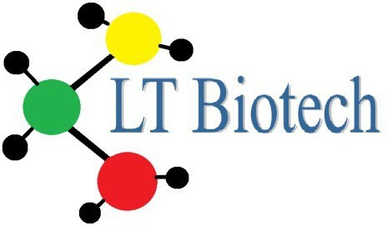
UAB “LT Biotech”

Į.K. 302303586, PVM kodas LT 100004741118,
Rugių 21-24, LT-08419, Vilnius Reg. Nr. 127918, V.Į.
Registrų centras Vilniaus filialas
Tel/fax +370 5 216 02 27

Fetal Bovine Serum, IgG Stripped

Product Description
Serum is the blood component that can be obtained after coagulation and by removing cellular components. Besides serum proteins it contains, e.g. growth factors, amino acids and hormones. This comprehensive mix makes serum one of the most important supplements, supporting cells to grow and proliferate in vitro cell culture.
Of special interest is the fetal bovine serum (FBS). It is especially rich in growth factors and is particularly low in antibodies, which may influence the cell culture work.

FBS is processed through protein A-Sepharose columns to reduce the IgG content of serum to below 5 µg/ml. This process is gentle to the product and ensures an unimpaired growth promotion. The specially treated FBS has a very low IgG antibody concentration and is outstandingly suitable for hybridoma cell culture. Thereby, the IgG stripped FBS facilitates the purification of monoclonal antibodies.

Product | Origin | Volume | Cat. No.
Fetal Bovine Serum IgG Stripped | Collected in South America | 100 ml  500 ml | LTFBS-SA100IGD  LTFBS-SA500IGD
Product Specifications
pH | 6.8 – 8.2
Osmolality | 240 – 340 mOsm/kg
Endotoxin | As reported
Total Protein | 3.0 – 4.5 g/dl
IgG | < 5 µg/ml
Albumin | As reported
Hemoglobin | As reported
Mycoplasma | Not detected
Virus tested for | PI-3, BVDV, BVDV-AB, BHV-I
Sterility | Tested
Storage | Store at ≤-15°C

UAB “LT Biotech”

Į.K. 302303586, PVM kodas LT 100004741118,
Rugių 21-24, LT-08419, Vilnius Reg. Nr. 127918, V.Į.
Registrų centras Vilniaus filialas
Tel/fax +370 5 216 02 27

Additional optional treatments

Heat inactivation
Heat inactivation will inactivate the complement system, antibodies and other active enzymes. It has to be done in a carefully controlled process in order to avoid damaging the cell growth promoting properties of the serum and reducing the formation of unwanted precipitates.
The process involves heating the serum in a shaking water bath at exactly +56°C for 30 minutes. The shaking will help avoid the formation of protein and other forms of precipitates. After 30 minutes the serum is then cooled back down to room temperature as quickly as possible to avoid excessive exposure to heat which can damage e.g. growth factors and vitamins.

Gamma irradiation
Capricorn Scientific has established process parameters and controls for maximum inactivation of contaminants by an innovative gamma irradiation process in small sized boxes at 25 – 35kGy. When FBS bottles are arranged in a pallet during gamma irradiation, high irradiation doses (58 kGy) are necessary to irradiate the centrally located bottles with the required does (>30 kGy). This and the associated higher temperatures may affect the serum quality. If the irradiation is performed in single boxes, the maximum does of irradiation is performed in single boxes, the maximum dose of irradiation does not exceed 38.7 kGy. Gentle irradiation as used by Capricorn Scientific is less likely to affect final serum quality.

Quality control
Only sera batches which pass our strict quality control are released for sale. Standard parameters which are determined include pH, osmolality, content of protein, albumin, IgG and hemoglobin, endotoxin level, sterility, mycoplasma detection and virus testing.

Precautions and Disclaimer
This product is for research use only. Please consult the Material Safety Data Sheet for information regarding hazards and safe handling practices.

